Water treatment Replica

Urinrinoghene L Omughelli

TEAM 4

Table of Contents

Team Contact Information 1

Design Activity 1 4

Subtask 1 ­ Task 1 5

Subtask 1 ­ Task 2 13

Subtask 2 15

Subtask 3 18

Design Activity 1

Stakeholders:

* World Health Organization
* People and communities affected by the Ebola virus
* Biomedical engineers
* Health workers

Functions:

* Sort and store 75 marbles of varying sizes and colors
* Dispenser must efficiently dispense one marble at a time
* Change speed at which the marbles are being dispensed

# 

# Subtask 1 ­ Task 1

Objective (Identifying the Need):​ A pellet dispenser capable of dispensing a marble at a time.

Understanding the Need: This project will replicate a water treatment system and provides a supporting technology that introduces antivirals to wells and other water bodies to treat water. The pellet dispenser must dispense one marble at a time and stop on command.

Possible Solutions: An upright cardboard box attached to a cardboard container that holds 75 marbles. The marbles roll down through a path that leads to two wheels connected to two motors on both sides of the robot. The wheels spin the marbles and dispense them one at a time. The wheels stop spinning on command to stop.

Define the Solution: The wheels occasionally dispensed two marbles at a time. To stop this, the speed at which the wheels rotated has to be modified in the code and a stopper should be put in order to avoid a small and a large marble from spinning through the wheels at the same time.

Implement the Solution: Lego pieces were built around the path leading to the wheels, a stopper was put in between the wheels and the speed in the was increased to allow one marble to be dispensed at a time.

Meeting Times:

September 21th, 2018: 4:10 PM

* This was the first meeting for subtask one. The team came up with design ideas, which was the first step towards achieving this task. The first idea worked better and the robot was built based on this idea. Two wheels of the same diameter were connected to motors which enabled it spin the marbles that passed through them. The code was written in C++ and labVIEW and no significant amount of errors were experienced. Design flaws were noticed and modifications to the design were suggested.

September 23th, 2018: 4:30 PM

* This meeting was for the primary purpose of implementing further modifications which were discovered from the previous meeting. Lego pieces were added to prevent the marbles from falling off the path leading to the rotating wheels. A stopper was added to the top of the wheels to prevent more than one marble from passing through the wheel. The motors were built and connected at an angle that enabled the marbles to roll down and marble container was built to allow for 75 marbles to be held. No correction to the C++ and labVIEW code was necessary at this point.

September 25th, 2018: 3:00 PM

* During this meeting, a container was built using cardboard boxes. The container was supported by two rods made of cardboard that acted as an incline for the container and enabling the marbles to fill into the the dispenser. After running the code, some of the marbles were jammed in the wheel but this was fixed by replacing one of the wheels with a different one. Short lego pieces were also used to act as a support and avoid marbles from falling off the dispenser.

Final Design and Results:

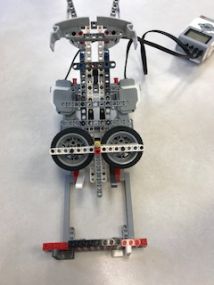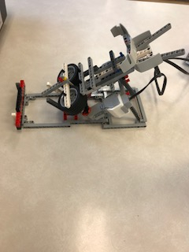

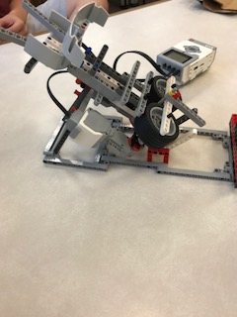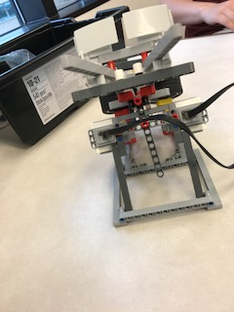

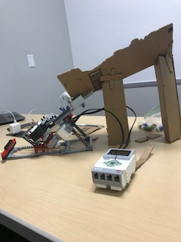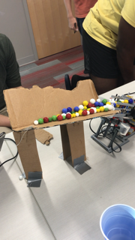

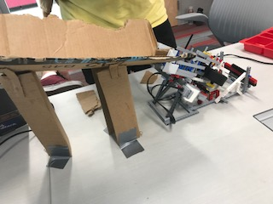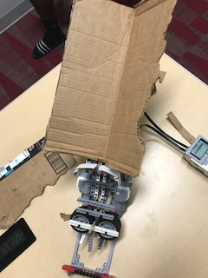

This design proved most successful in doing the tasks that needed to be completed. In the end it was capable of dispensing all the marbles without allowing two marbles pass through the wheels at the same time. It needed tweaks to the design but nothing too serious that could not be modified easily.

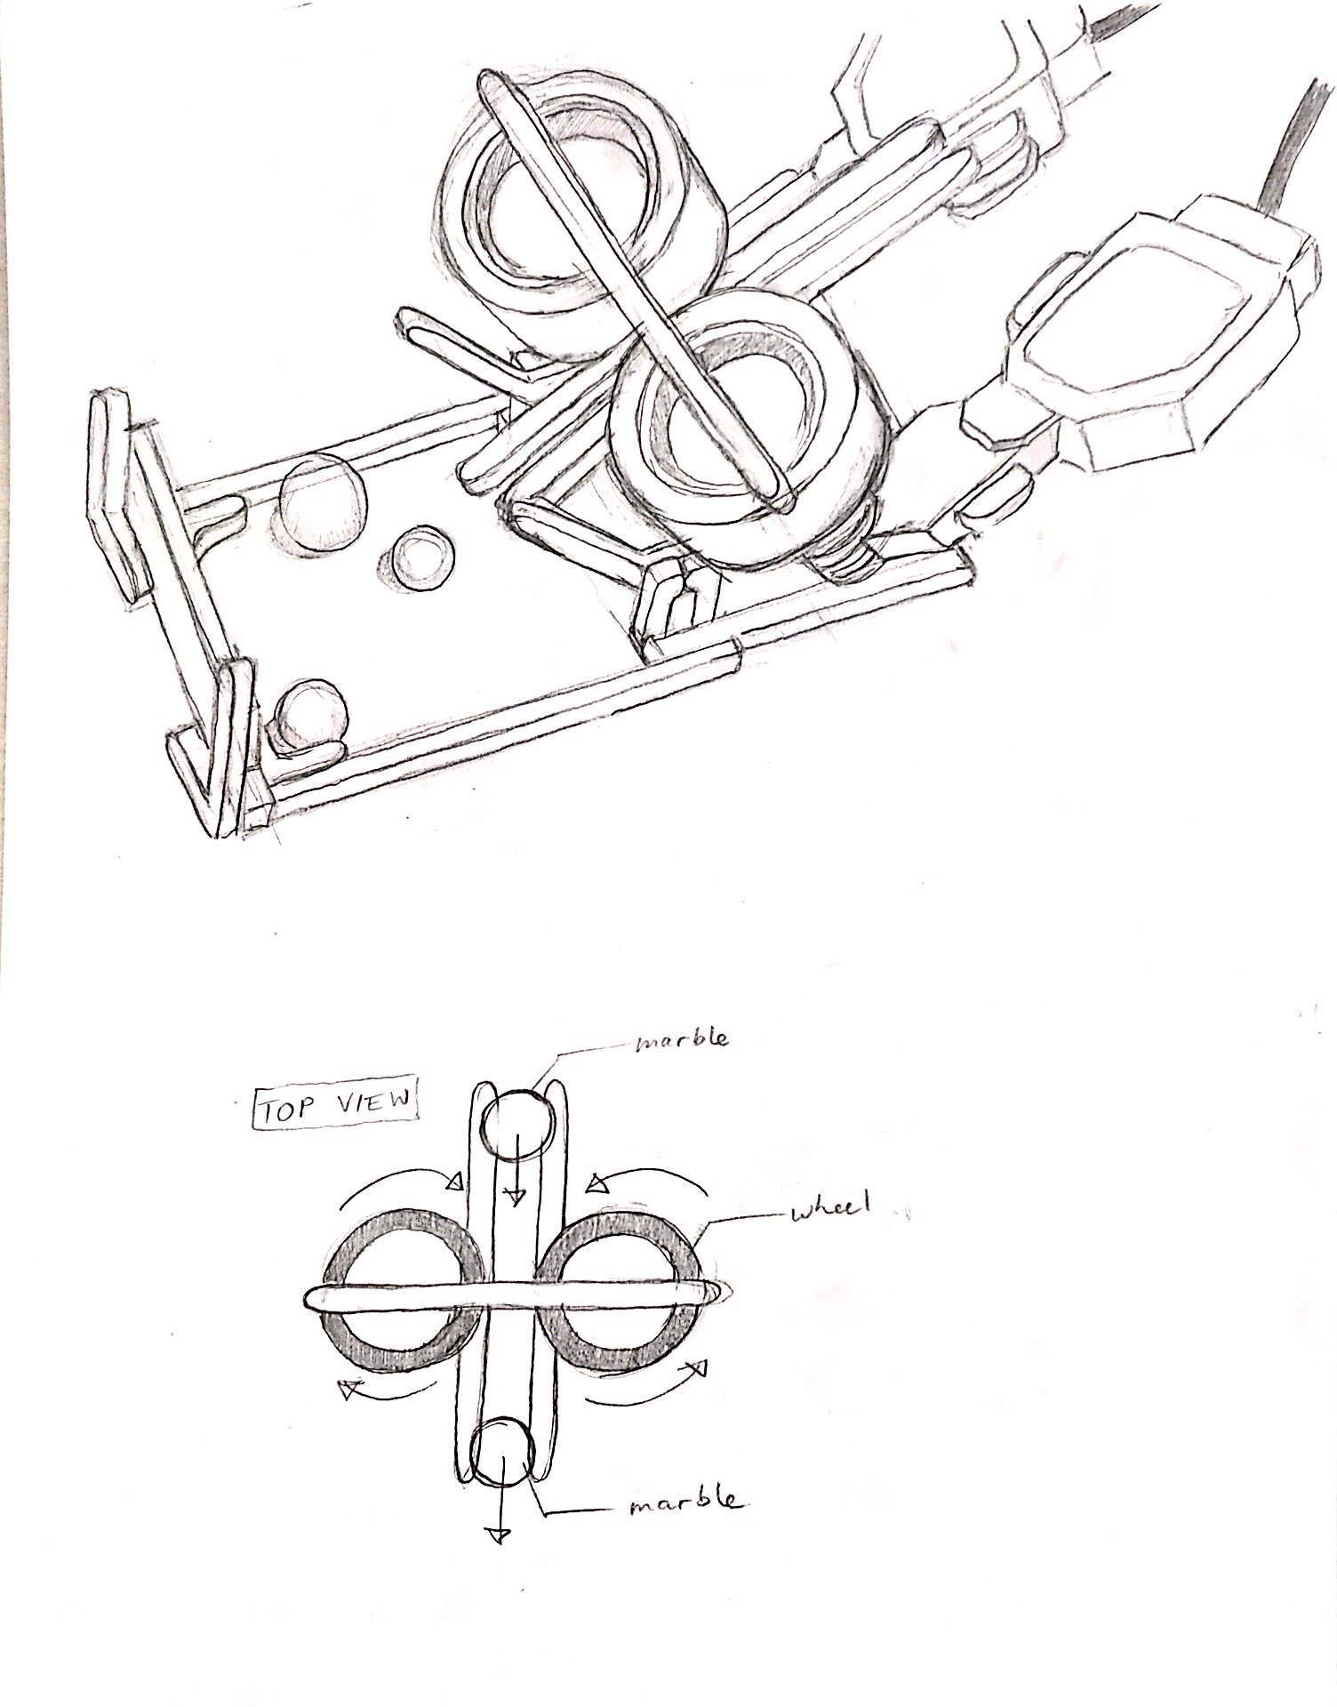

Sketch of the first demo for the dispenser that we believe can satisfy the requirements of the upcoming subtask and the final project.

Code for the Dispenser:

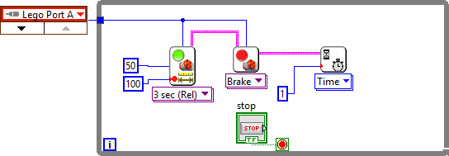

# 

# Subtask 1 ­ Task 2

Objective (Identifying the Need):​ A pellet dispenser capable of dispensing a marble at a time.

Understanding the Need: This project will help provide a supporting technology that introduces antivirals to wells and other water bodies. The pellet dispenser must dispense one marble at a time and stop on command.

Possible Solutions: An upright cardboard box attached to a cardboard container that holds 75 marbles.The marbles are held by a cardboard container placed behind a moving conveyor belt. The belt stops spinning on command to stop.

Define the Solution: The conveyor belt dispenses a marble at a time as the lego pieces attached to the rotating conveyor belt picks up the marble.

Implement the Solution: Lego pieces are fixed into a conveyor belt and a cup which act as the receiver is placed in front of the dispenser. The dispenser can change speed and stop on command.

Dispenser upgrade

During our demonstration, we discovered that the container which was initially designed to hold 75 marbles, did not hold all marbles at once. This was due to the fact that the width of our container was not large enough and the support was minimal. Although our dispenser could stop and change speed on command which meant that our labview code worked just fine, as the marbles passed through the two rotating wheels, small and big marbles got stuck between the wheels. In other words, the idea behind our dispenser was unique but these glitches reduced the efficiency of our marble dispensing all the marbles, one at a time. Therefore, our team decided to go with team 1’s design which proved to meet all requirements of task 1.

This dispenser included a conveyor belt with lego pieces fixed on each side of the belt and at equal distances. The conveyor belt rotates while the lego pieces lifts up a single marble from the container attached behind the conveyor belt, the lego is then dispensed into a cup placed right in front of the dispenser. The labview code also proved to work well as it could stop and change speed by command at any time.

Meeting Times:

September 18th, 2018: 6:25 pm

* This was the first meeting with our mega team. During this meeting, a decision was made to use our mega team’s dispenser as it had no fault and received an A grade for the demo. Their dispenser included a conveyor belt which had two lego pieces inserted side by side into the belt, this mechanism allowed the conveyor belt connected to a motor to rotate and with the lego pieces, a marble was picked up from the container and dispensed into a cup.

List of Requirements for both teams:

1. Have structural capability to hold 75 pellets
2. Dispense 75 pellets individually, one every second
3. Have a mechanism to stop dispenser at any time

Team Rankings (Graded out of 5)

|  |  |  |
| --- | --- | --- |
| Requirement that | Team 1 Dispenser | Team 2 Dispenser |
| Doesn't dispense 2 marbles at a time | 5 | 4 |
| Consistently dispenses marbles | 4 | 1 |
| Structurally sound | 5 | 1 |
| TOTAL | 14 | 6 |

Selection of the prototype:

* Team 1 prototype is most likely to succeed.
* From team 1, we’re going to keep:

Entire design

Code for dispenser

* From Team 2, we’re going to keep:

­ Idea to scan marble as part of the dispenser

Ranking Method Logic:

The criteria chosen for the updated dispenser design is based off of a qualitative observation of each teams prototype during demonstration. Overall, Team 1’s design was fairly flawless. There was also a need to change the angle of the container to reduce the number of double dispensing of marbles, which was easily fixed. As a result, Team 2 will discontinue the use of their dispenser.

Subtask 2

Picture of the Prototype:

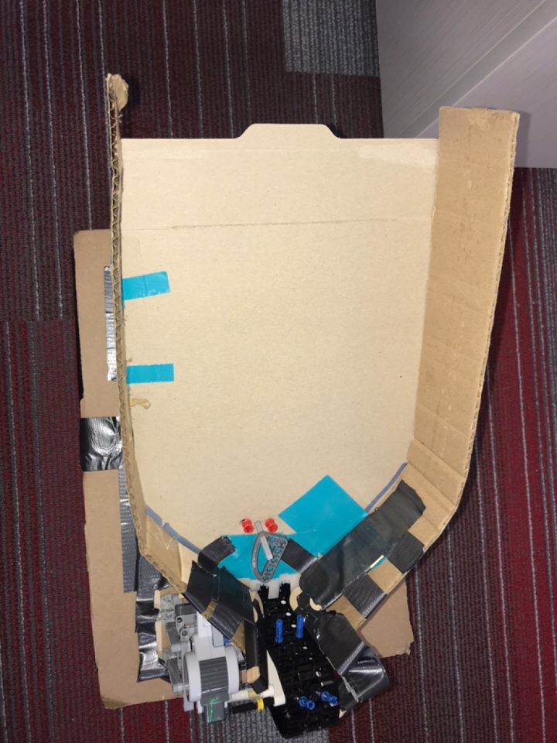

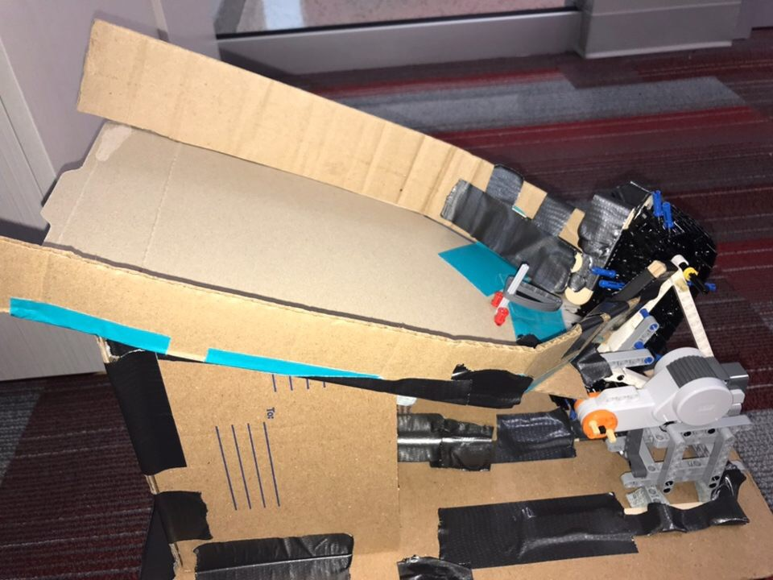

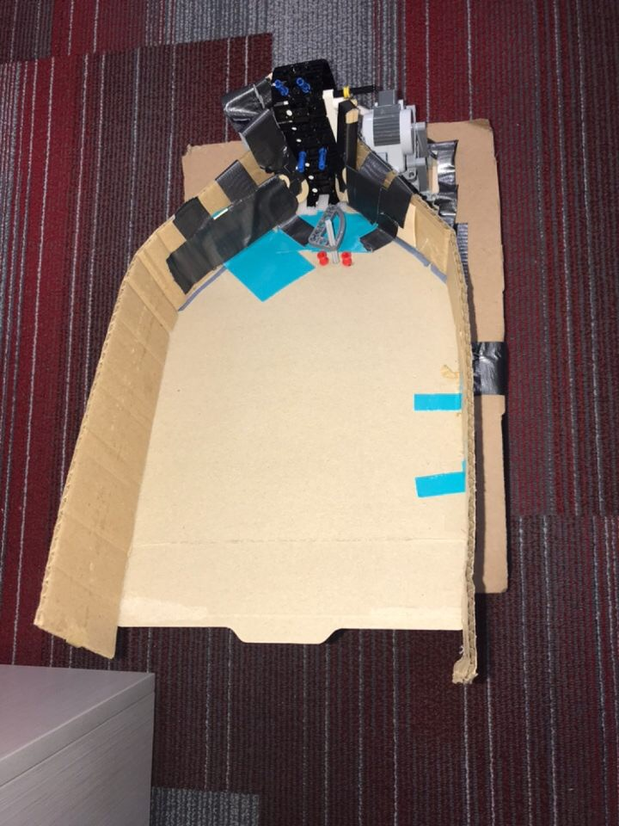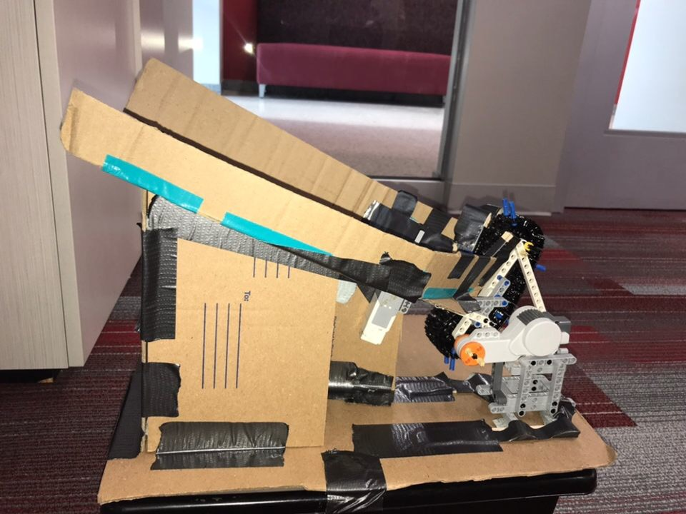

The container used by team 1 proved to hold more marbles due to the width and supportive edges around the container.

Code for the new Dispenser:

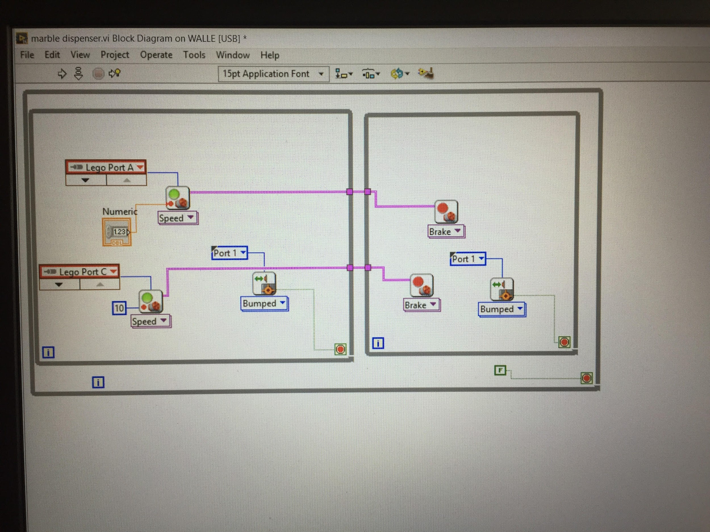

Results of the Demonstration:

No error was encountered during our demonstration of the dispenser. Therefore we are now working on the second part of the project which includes barcode reading.

# Subtask 3a :Barcode Reader

*Team 1 and 2*

1. Build Dispenser (Team 1 and 2)
   1. Determine design specifications
   2. Brainstorm and create models
   3. Assemble apparatus
   4. Write labview code
   5. Test
   6. Debug and fix errors
   7. Retest
2. Build Barcode Reader (Team 1 and 2)
   1. Determine design specifications
   2. Design how barcode reader and dispenser work together
   3. Brainstorm and create models
   4. Buy Materials
   5. Assemble apparatus
   6. Code
   7. Test
   8. Debug and fix errors
   9. Retest

DESIGN PROCESS

Objective (Identifying the Need):​

The objective of Subtask 3 was to design a barcode scanner which could feed and scan a barcode, then produce a formula or recipe depending on the barcode scanned.

Understanding the Need:

To complete this subtask, it is understood that the color sensor will be used for the scanning portion. A method of feeding the barcode through the scanner is needed as well as a was to easily position the color sensor in order to properly read the barcode. A method of turning the colors scanned into a recipe and understanding the recipe is also needed.

Possible Solutions:

Possible solutions for this design would be to use the color sensor as the meth of scanning. Wheels would more than likely be used for the feeding of the barcode through the scanner. Some sort of base would have to be built to support the structure and give a foundation for the barcode to be run through. A portion of the code will need to focus on reading the input and displaying a corresponding output.

Define the Solution:

The barcode reader utilizes a combination of the color sensor, a motor, and wheels, in order to completely scan a barcode and analyze the desired recipe. Our setup was constructed with a cardboard base with a frame that positions the color sensor directly above the base. A single motor is attached to the frame and is connected to 3 wheels using gears. The motor spins the wheels along the base which feeds the barcode through the scanner. When first started, the program of the scanner will continually turn the wheels, or feed the barcode, until a “black” color is recorded. This initial “black” color tells the program that a barcode is present, and the wheels begin to feed the barcode through in increments. At each increment the color sensor scans the color and either records a 1 for black or a 0 for white. Once the barcode has been scanned the pattern of 1’s and 0’s will be read and interpreted, then the corresponding recipe will be displayed.

Implement the Solution:.

Building the frame which supported the color sensor was relatively simple. By taping the frame to the cardboard piece, a solid foundation was constructed. Initially two wheels were used to feed the barcode through, however by improvement through trial it was concluded that using a third wheel at a different position proved more effective. Lastly A white slip of paper was put across the cardboard because upon starting the program the color sensor would assume the cardboard base was the initial “black” reading.

Meeting Times:

October 22nd, 2018: 5:00 pm

* This was the first meeting for the barcode reader. During this meeting, we came up with ideas for our barcode reader and a labview code was written. After coming up with various ideas and taking into account their pros and cos, we came to a decision which included a barcode reader consisting of a color sensor, motor, and two spinning wheels connected to a motor. the barcodes will be placed under the wheels and as the wheels rotate, the barcodes slide under the color sensor which would detect the color- a black or white- and output the corresponding number (1 for a black and 0 for a white).

October 30th, 2018: 5:00pm

* During this meeting, our team built the barcode reader. There were a lot of trial and errors before we built a design that we felt had met all the requirements for our barcode reader to work efficiently. The barcode reader was placed on a cardboard with a white paper taped to it in order to prevent the color sensor from detecting the brown color on the cardboard. In addition, we added a handle made out of legos and attached to the top of the reader in order allow the reader to be pushed up easily whenever a barcode was passed under the wheels.

November 1st, 2018: 2:00pm

* A final test was run on the reader to ensure that no difficulties would be encountered. We had to change up our labview code and add a touch sensor to enable us easily start and stop the reader by pressing the touch sensor.

Design and Results:

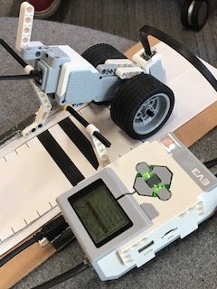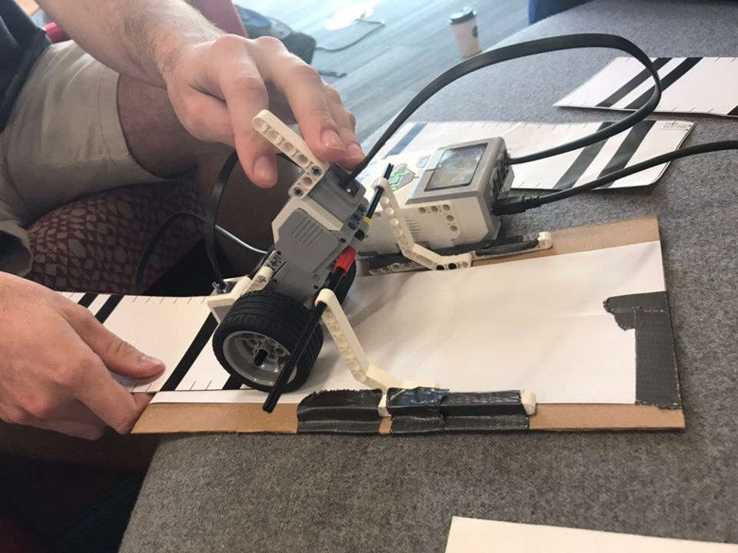

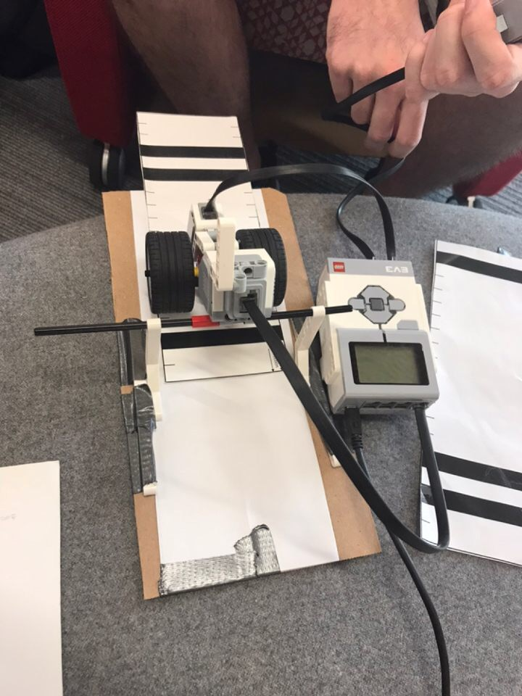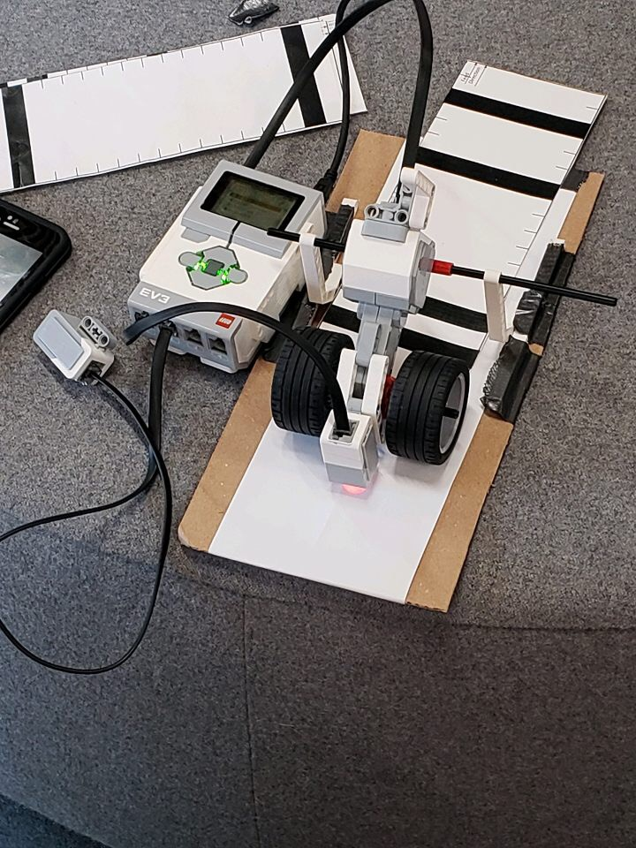

This design worked perfectly and was able to read all the barcodes with no errors encountered. There were a few changes made to the labview code but aside from that everything worked well.

Sketch of Barcode Reader

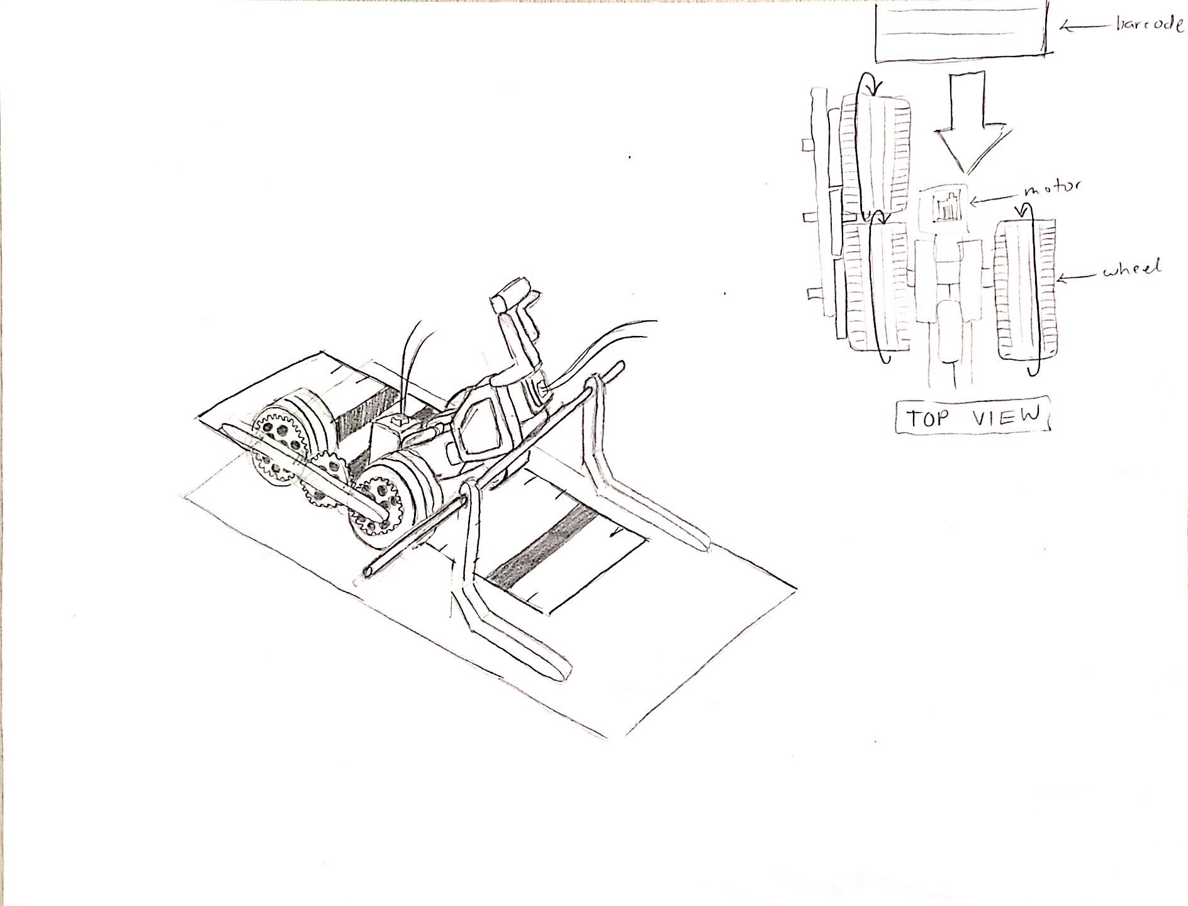

Sketch of design for the barcode reader that worked perfectly and we believe meets all requirements of the task.

Code for the Barcode Reader:

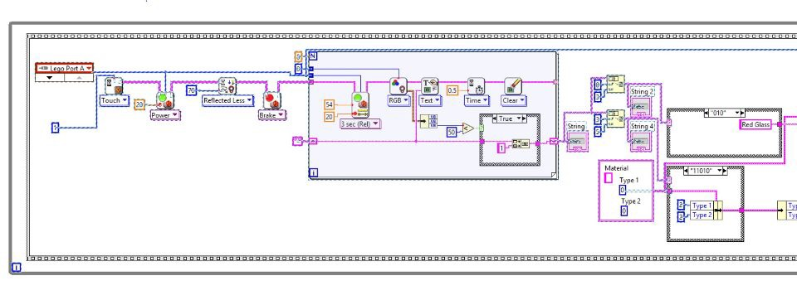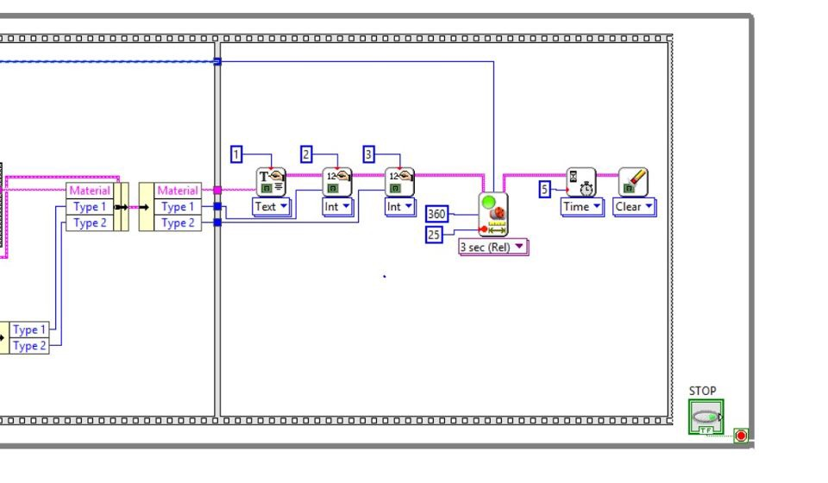

Subtask 3b :Barcode Reader

Work Breakdown Structure for Subtask 3 Part 2: The Marble Sorter

1. Create Size Sorting Apparatus
   1. Draw up design
   2. Buy materials
   3. Assemble apparatus
   4. Perform tests
   5. Fix errors
   6. Retest
2. Create Color Sorting Mechanism
   1. Add color sorting design to the size sorting design
   2. Buy materials
   3. Assemble mechanism
   4. Code
   5. Perform tests
   6. Debug and fix
   7. Retest

DESIGN PROCESS

Objective (Identifying the Need):​ Prototype must accept a pellet and indicate the material, size, and color of pellet and sort the pellet into the correct bin. In addition, data must be displayed on Lego brick or on a computer.

Understanding the Need: A marble sorter which would be used to separate different colors and sizes of pellets and provides the support technology chemical treatment to improve water quality.

Possible Solutions: A sorter which comprises of a color sensor used for reading the pellets and a motor which is connected to a lego piece that helps to push the pellets into their respective bins. The sensor has to be placed beneath the marble so that the sorter built above can easily push the pellets into their respective bins. The sorter is connected to the dispenser which was already built in task 1 and a container behind the dispenser is filled up with marbles and the dispenser dispensed one marble at a time into another container in order for the marbles to sorted into their desired bins.

Define the Solution: A color sensor reads the marble indicating the color, size, and material of the marble on the computer and lego brick. The colors are read based on the numbers assigned to the colors and according to the barcode. The barcode determines what material is needed;therefore, after the color sensor reads the marbles, the desired marbles are pushed one at a time into the water dispensary pile and the ones that are not needed are pushed into the trash pile with the aid of a lego piece.

Implement the Solution:.The entire code for the dispenser, barcode, and sorter is run in order to accomplish the goal of building a support technology for water treatment plants. A marble is dispensed into a container, the marble rolls down the path and stops when it gets to the color sensor, the color sensor then reads the marble and outputs the color, size and material of the marble eg white steel. If the marble’s readings matches the barcode, then the marble is sorted to its designated bin.

Meeting Times:

November 8th, 2018: 4:00 pm

* This meeting was for the sole purpose of discussing various design ideas for the pellet sorter. After the team came up with various ideas, the best option that proved to have minimal flaws was chosen. A C++ code was written and the team began building the sorter which consisted of a motor, a color sensor and a handle which was made of lego pieces.

November 11th, 2018: 3:30pm

* The main building of the sorter was done during this meeting. Some difficulties like figuring out the best position for the color sensor and sorter were encountered but after several trials and errors, we were able to build our desired sorter. A motor was connected to the side of the conveyor belt of the marble dispenser and the color sensor used to read the marbles was positioned beneath the sorter. The motor right above the color sensor was connected to a handle which basically acted as a means of sorting the marbles to their desired container. After building the sorter, there were still some adjustments that needed to be made to achieve our goal.

November 13th, 2018: 2:00pm

* During this meeting, all final changes were made to both the code and the sorter by debugging and retesting. At the end, the sorter was able to use the color sensor to read the type and color of the marble according to the barcode.

Design and Results:

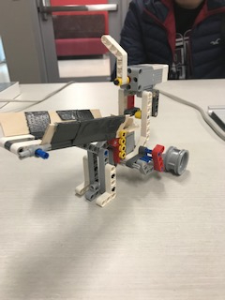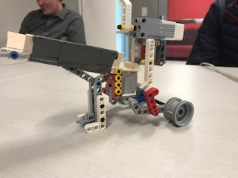

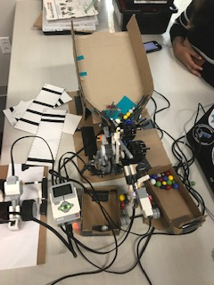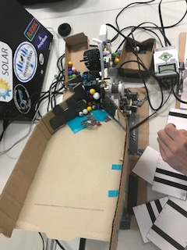

Sketch of sorter

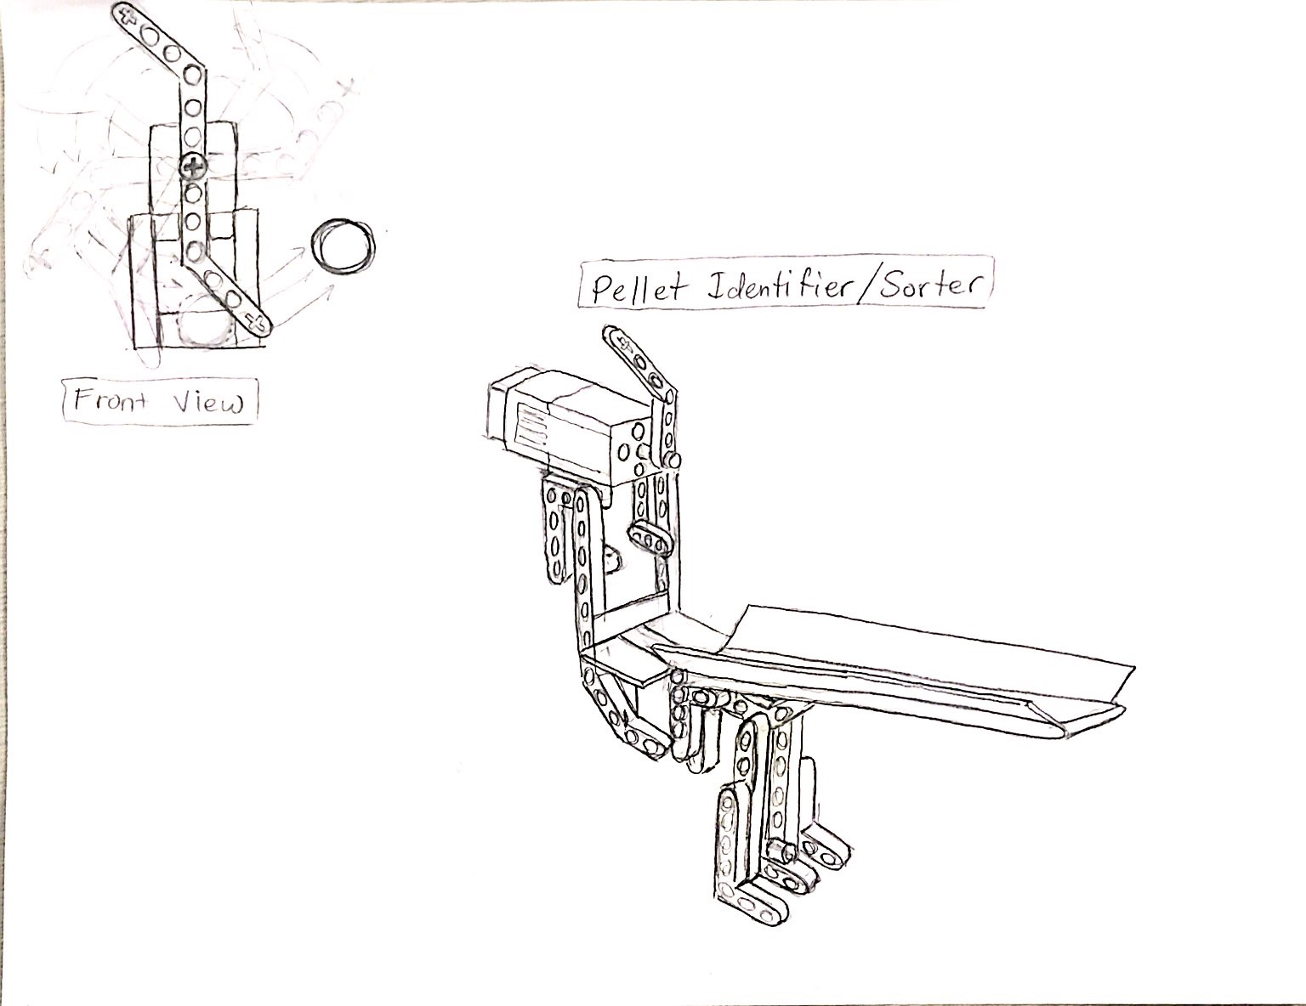

Code for Sorter

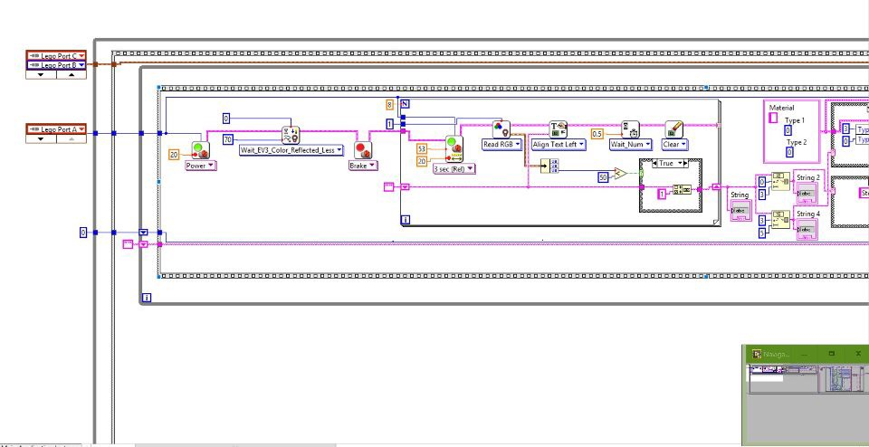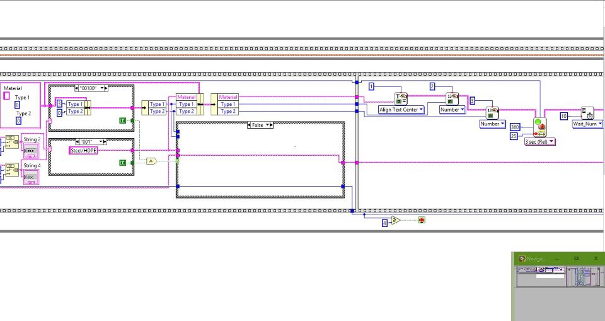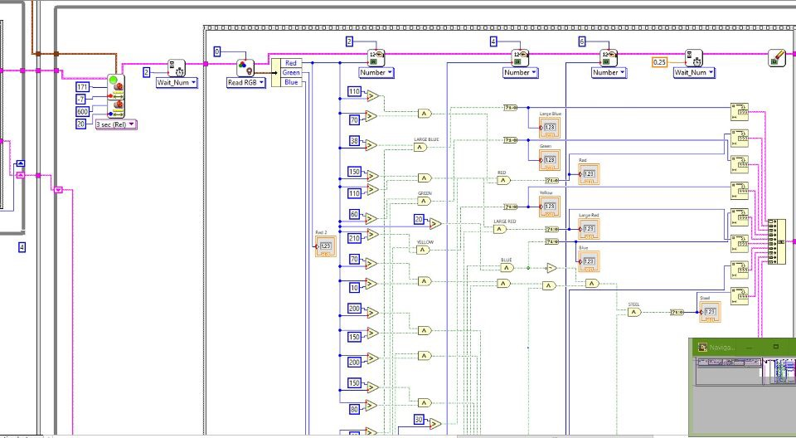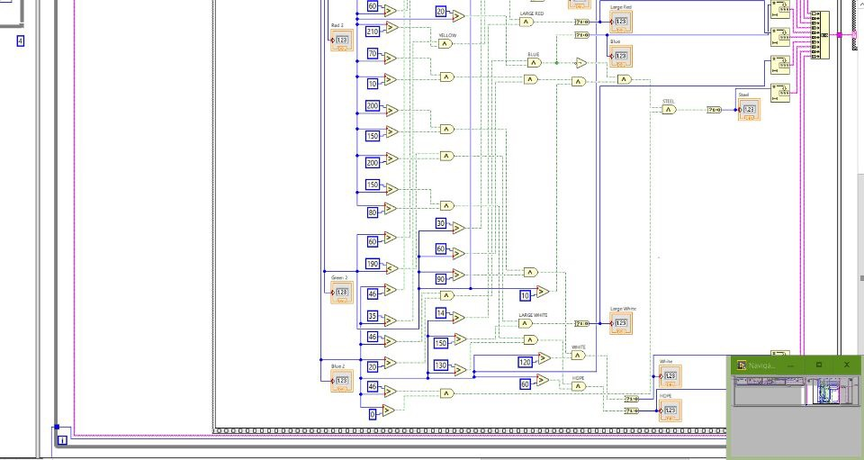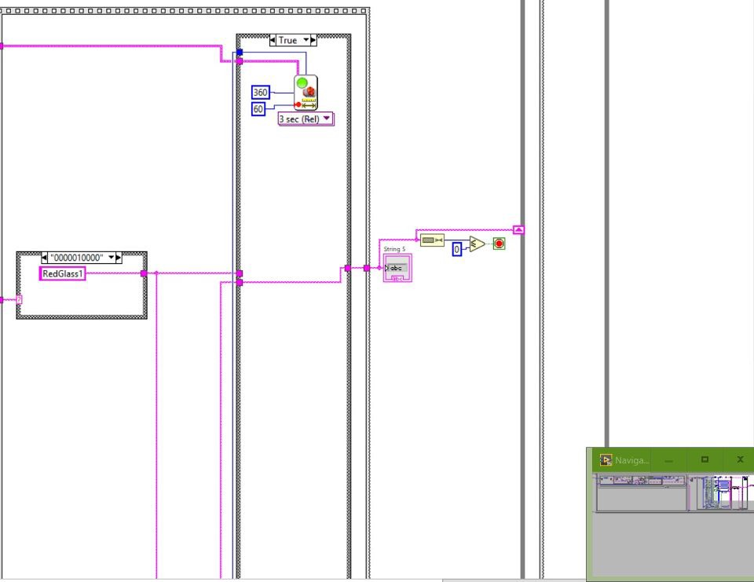

Subtask 4

**DESIGN PROCESS**

Objective (Identifying the Need):​ For this task, we needed a design that would dispense the marbles in the trash pile back into the dispenser. This design would be implemented into out prototype for our antiviral delivery system in order to make our technology more efficient

Understanding the Need: This design must efficiently dispense the trash pile from the sorted marbles back into the dispenser so that they can be resorted and put into the desired bins based on their size, color and material and according to the barcodes.

Possible Solutions: In order to have the trash pile resorted, a catapult which initially acted as the trash pile must deliver the marbles back into the dispenser. Another solution would be to design a separate robot that would lift all the marbles but the idea would require more sensors and lego pieces.

Define the Solution: The trash pile made out of cardboard acted as the catapult/electromotive arm. A motor was attached to the catapult and after a few sections after some marbles had been sorted into their desired bins, the motor would rotate and cause the catapult to dispense into the dispenser. i.e the motor lifts the catapults in a backward motion.

Implement the Solution:.

The design was built and worked well with the labview code written. All the marbles that were needed were disposed into the desired bin while the other marbles that were not indicated according to the barcodes were put into a trash pile which was “recycled”

Meeting Times:

November 18th, 2018: 2:00 pm

* During this meeting, our team discussed what our aim was for this task. Several ideas were brought up; However, the team decided that a catapult design would be better in order to effectively implement the objective of this task. A labview

Our design idea is a catapult which is the trash pile (made out of cardboard). A motor attached to the trash pile is programmed to rotated at certain time periods. As soon as enough marbles have been disposed into the trash pile, the motor connected to the trash pile rotates and the catapult feeds the dispenser with the marbles. A labview code which we believed would accurately perform the task was written.

Meeting Times:

November 8th, 2018: 3:00 pm

* The catapult (trash pile) had already been built during the previous task. Therefore, we only had to attach a motor with the aid of lego pieces to the catapult. the entire sorter was tested several times in order to ensure that our design worked well with the previous requirements of the marble sorter and after several trial and errors, we finally achieved our goal.

Final Design and Results:

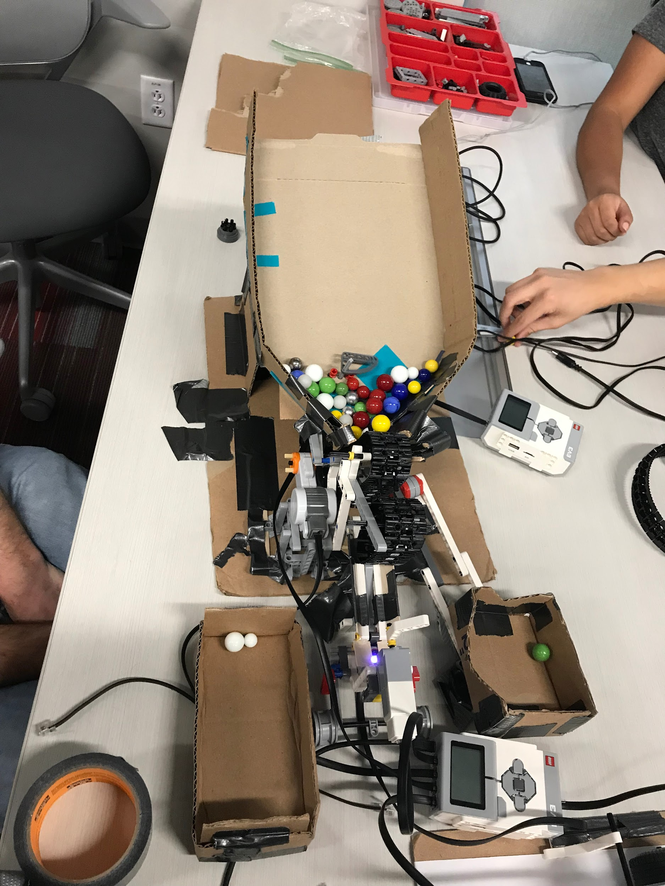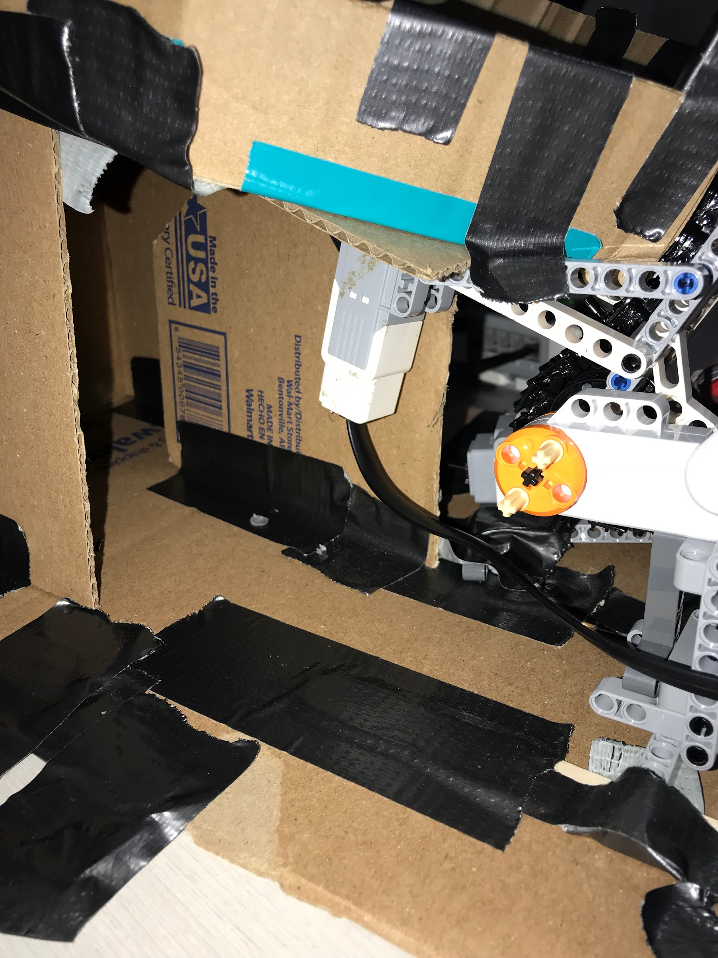

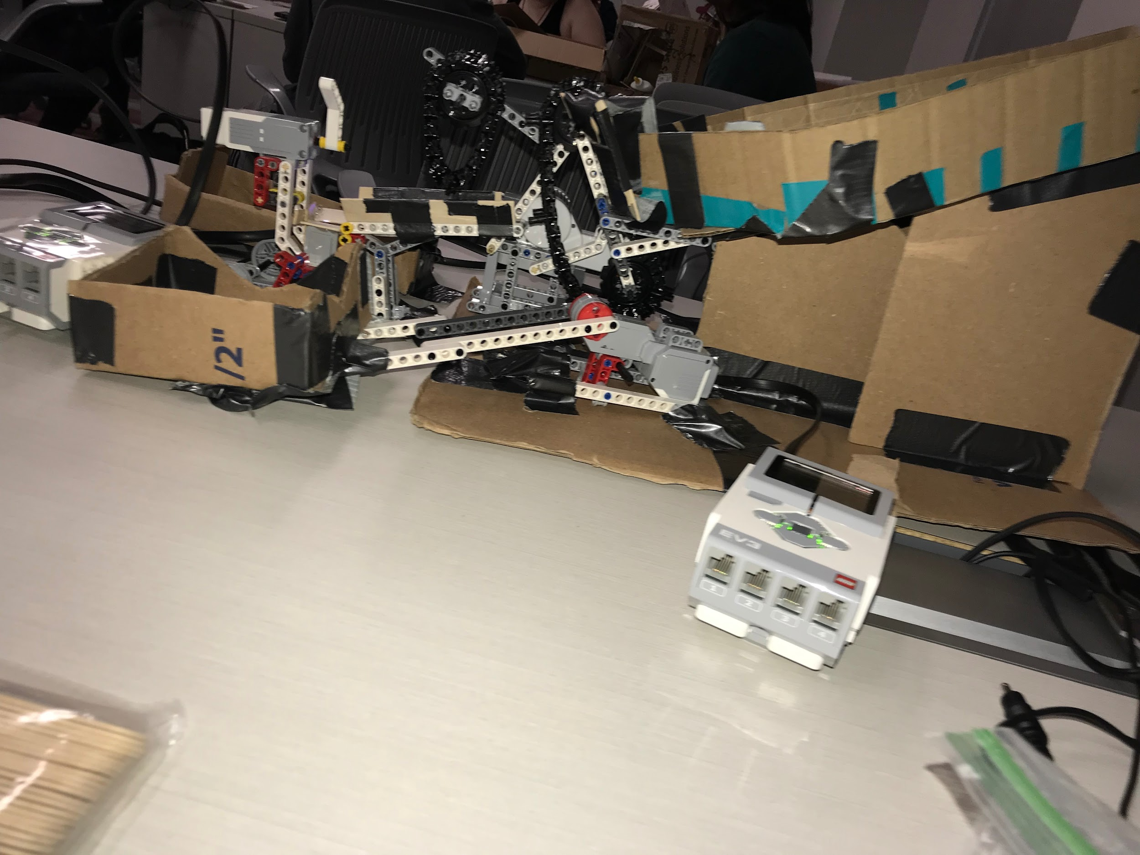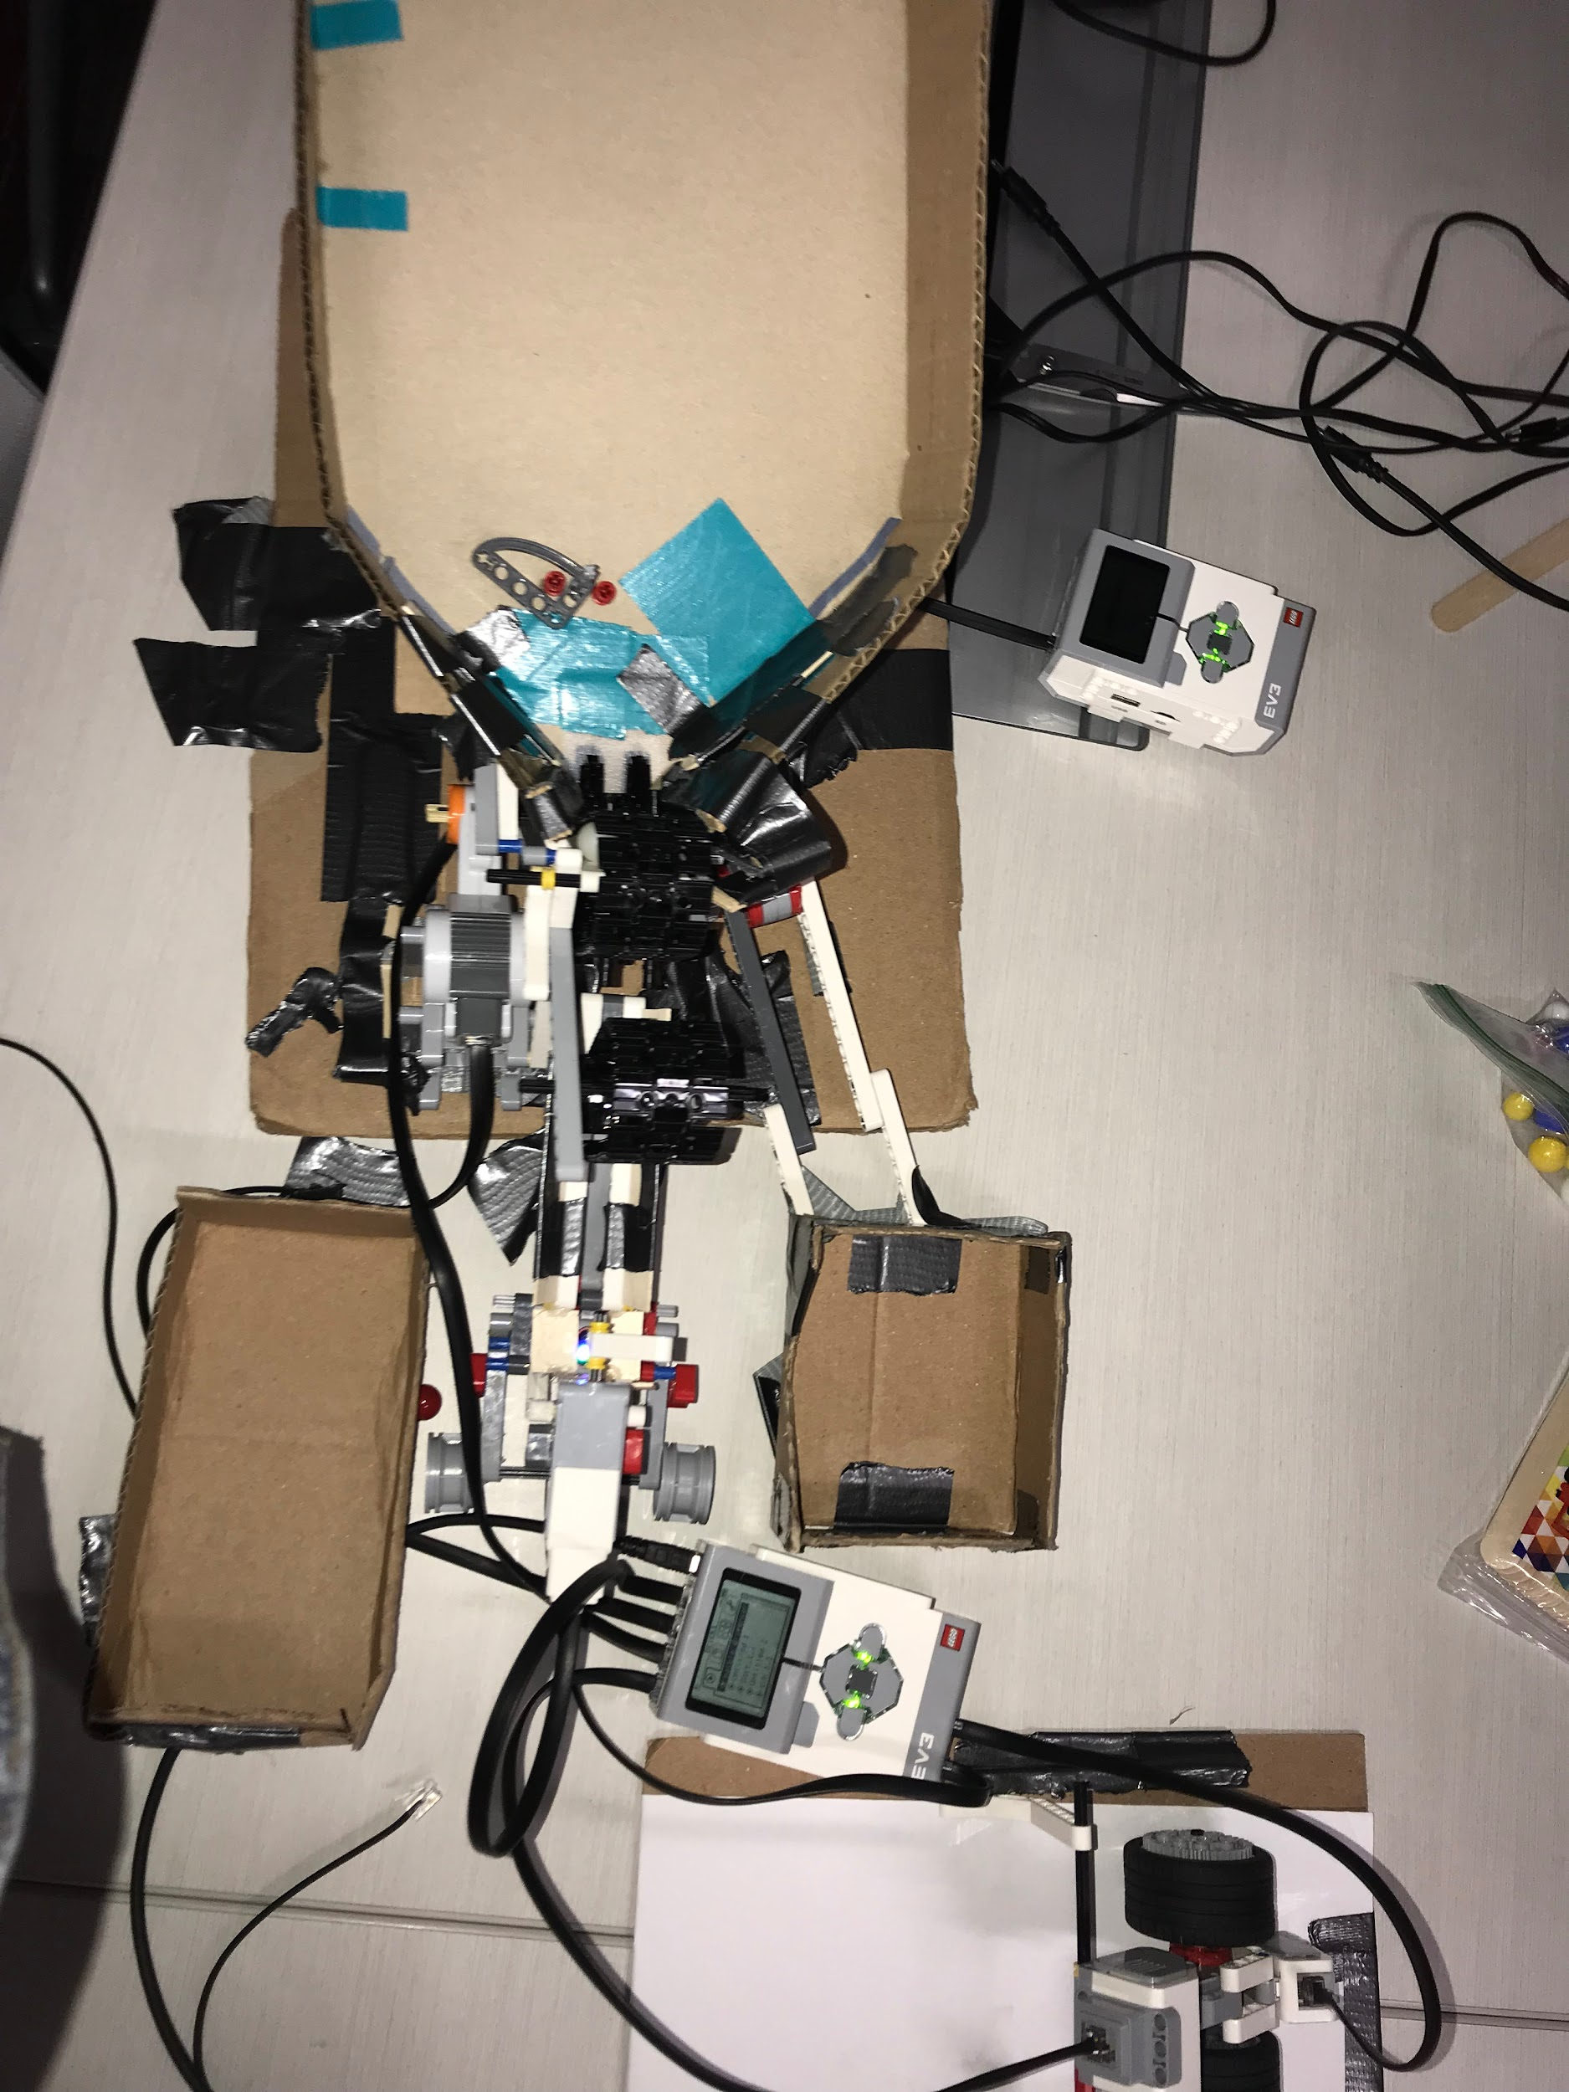

final code





Comments on Sample Pellet and Information Flow between Components of Final Sorter

The marble sorter task was a success. Our design and labview code worked well enough to give the desired output. The dispenser dispensed a marble at a time and the color sensor was able to efficiently read all marbles and display the size, color and material according to the barcode. The sorter also worked efficiently by disposing all marbles that were not required into the trash pile and keep the ones that were needed in a separate bin (water dispensary pile). The final task enabled the marbles in the trash pile to be resorted with the help of an electromotive arm. Although we faced some difficulties in solving some of tasks, we achieved our goal of creating a prototype that would be used in an antiviral delivery system.